GC1 - 1: Identify and describe the major print/output processes.
List and apply the technical production flow from conception to delivery.
Identify major occupations in the graphic communications industry.

- Which of the following is the identifying characteristic of relief printing? L1
  - Ink is applied through a stencil directly to the surface to be printed on
  - Oil and water do not mix
  - The printing surface is raised above the printing plate
  - The image is recessed on the printing plate

- Which of the following would use flexography to apply an image to its surface? L2
  - Candy bar wrapper
  - Hundred dollar bill
  - Movie poster
  - Magazine

- Which of these printing processes is the most cost effective choice when printing 5000 full color brochures? L2
  - Screen
  - Lithographic
  - Relief
  - Digital

- Which printing process is based on the premise that water and oil do not mix? L1
  - Screen
  - Digital
  - Relief
  - Lithographic

- Which printing process is accomplished by cutting into a cylinder? L1
  - Relief
  - Gravure
  - Screen
  - Digital

- Which of the following printing processes forces ink through a mesh? L1
  - Gravure
  - Relief
  - Screen
  - Lithographic

- Which printing process takes an image directly from a computer and applies it to a variety of media? L1
  - Digital
  - Gravure
  - Relief
  - Lithographic

- A customer has requested you print their company logo on t-shirts. Which of the following printing processes would you use to complete this order? L2
  - Gravure
  - Screen
  - Lithographic
  - Relief

- A small business comes to you and wants to personalize 500 pre-printed flyers. Which printing process would provide the most efficient solution? L2
  - Digital
  - Gravure
  - Screen
  - Relief

- What is the first step in the technical production flow for a client? L1
  - Inform the client of the cost of the production
  - Go to the computer and begin designing
  - Creature mockups for the client
  - Assess and determine the needs of the client request

- What does it mean to determine the appropriate vehicle for creation? L1
  - Choose a delivery method for a product
  - List all methods and then use Adobe Illustrator to determine the best one
  - Choose a program to use to create a design
  - Determine whether the creation should be direct or indirect

- When planning to create an advertisement campaign, which of the following is NOT necessary to know before beginning? L1
  - Intended uses
  - Layout specifications
  - Client budget
  - Age of the business

- A client asks you for a range of new promotional materials. Which of the following is NOT used in RGB color mode? L2
  - Tv
  - Magazine spread
  - Projection system
  - Web site
- A client asks you to produce a new range of promotional materials to be used in their web presence. When formatting graphics to transmit to the client which of the following should NOT be used? L2
  - TIFF
  - GIF
  - BMP
  - JPG

- A new client comes to you for help. Their previous promotional material (business cards, flyers, brochures, etc.) are being produced at a very low quality. Upon questioning, you discover that the files being printed are formatted for web use. What is most likely the ppi of the files intended for web use and what should the dpi be for printing? L2
  - 72ppi and 120dpi
  - 72ppi and 300dpi
  - 300ppi and 120dpi
  - 200ppi and 72dpi
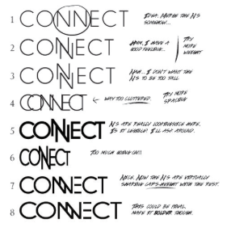
- What does the image depict? L2
  - Sketching
  - Leading
  - Proximity
  - Creative process

- Which of the following should be done after a rough design has been created and before going to production? L2
  - Consult with the client on any changes they would like made
  - Research the client and their target audience
  - Gather support materials to aid in your design
  - Publish design for consumer preview

- You have been asked to design a flyer for a community center event. Which of the following should be considered when beginning the design process? L2
  - Demographic of the neighborhood
  - Socio-economic status of the neighborhood
  - Sized of the neighborhood
  - Date of the event

- You have been asked to create an original business logo. This logo will be used on all promotional materials including business cards, television commercials and billboard advertisements. What design software would you use to create this logo? L2
  - Adobe Photoshop
  - Adobe InDesign
  - Adobe Illustrator
  - Adobe Dreamweaver

- You have been asked to create a logo and accompanying slogan for a local township campaign. Which of the following color combinations would be MOST likely to invoke a feeling of trust and security with the voters? L2
  - Blue & White
  - Red & White
  - Black & White
  - Green & White

- You are asked to create a new sign composition for a local law firm and present the following design mock up. You are told that they would like a “sleeker, cleaner, more luxurious” typeface. Which of the following would you do? L3
  - Use a brighter, bolder typeface
  - Add abstract shapes
  - Use bold, cursive fonts
  - Change to wide thin fonts in
caps with a lot of letter spacing

- Which of the following is the best measurement of graphic design digital proficiency/mastery? L2
  - C++ Certification
  - Java Scripting Exam
  - Adobe Certification Exam
  - Microsoft Developer Certifications

- Which of the options would LEAST likely allow you to pursue a career as a web designer? L2
  - High School Diploma
  - Associate’s Degree
  - Bachelor’s Degree
  - Technical School Degree

- Which of these tasks would a Graphic Designer most likely complete? L1
  - Creating commercials for airing on the television
  - Developing a database for customer relations
  - Creating advertisements for a customer
  - Updating code for a website

- A common way to advance your technical knowledge in a short period of time within the graphics industry is to obtain which of the following? L1
  - A masters degree
  - A specialized certificate
  - A general credential
  - A fine arts license

- Which of the following is the best pathway to a career in advertising? L1
  - Obtaining a Bachelor Degree in Advertising
  - Completion of the Adobe Certification Exam
  - Completion of Microsoft Developer Certificate
  - Obtaining a Web Design Degree

- Which of these options is NOT a career in the Graphic Communication field? L1
  - Graphic Designer
  - Web Designer
  - Illustrator
  - Computer Aided Design Technician

- Which of the options is most likely NOT a potential employer for a career in Graphic Communications? L2
  - Magazine Company
  - Law Firm
  - McDonald’s Corporation
  - Yourself

- Which of the options is a career in the filed of Graphic Communications? L1
  - Web Designer
  - Programmer
  - Computer Aided Design Technician
  - Systems Specialist

- Which of the options is a career in the filed of Graphic Communications? L1
  - Advertising Designer
  - Programmer
  - Computer Aided Design Technician
  - Systems Specialist

GC 1 – 2: Solve basic mathematical problems.
Solve basic linear measurement problems.
Solve conversion problems.

- If an image that is 480px wide is placed next to an image that is 384px wide, then how wide will the printed area be? L1
  - 864px
  - 764px
  - 894px
  - 794px

- If an image with the dimensions 768px x 960px is cropped to remove 384px from its height what will the new dimensions be? L2
  - 576px x 768px
  - 768px x 576px
  - 384px x 960px
  - 384px x 576px

- What is the printed area of an image that is 12” x 14”? L1
  - 26in²
  - 170in²
  - 52in²
  - 168in²

- If an image with an 18in width and 24in height is cropped to remove a 1in border from all sides what will the new dimensions be? L2
  - 16in x 22in
  - 17in x 23in
  - 16in x 24in
  - 18in x 22in

- If an image with a width of 192px and a height of 288px has its canvas increased 200% what will the new dimensions be? L2
  - 192px x 576px
  - 384px x 288px
  - 288px x 432px
  - 384px x 576px

- What is the decimal form of 1/8? L1
  - 0.12
  - 0.24
  - 0.125
  - 0.135

- Convert 1.125 in to a fraction. L1
  - 1 ¹/₁₆in
  - 1 ²/₈in
  - 1 ¹/₈in
  - 1 ²/₁₆in

- What percent is an image increased if the width is changed from 6in to 9in? L1
  - 150%
  - 130%
  - 120%
  - 160%

- What percent is an image increased if the height is changed from 96px to 158px? L2
  - 175%
  - 75%
  - 150%
  - 50%

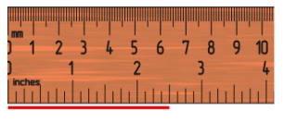
- Use the ruler shown to measure the red line below. What is the length of the red line? L1
  - 2.25in
  - 2.5in
  - 2.75in
  - 2.375in

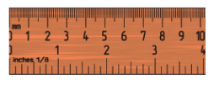
- What is the length of the ruler? L1
  - 3in
  - 4in
  - 3.5in
  - 10in

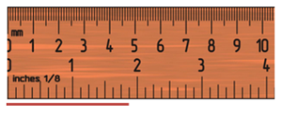
- Use the ruler shown to measure the red line below. What is the length of the red graphic in inches? L1
  - 1 ⁵/₈in
  - 2 ¹/₈in
  - 2 ³/₈in
  - 1 ⁷/₈in

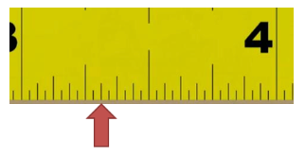
- What is the measurement the red arrow is pointing to in inches? L1
  - 3 ¹/₄in
  - 3 ³/₁₆in
  - 3 ²/₁₆in
  - 3 ⁵/₈in

- If an uppercase t (T) measures 0.166in what is its height in points? L1
  - 13pt
  - 14pt
  - 12pt
  - 11pt

- If a layout headline measures 44pt which of the following would be an appropriate body size? L1
  - 24pt
  - 10pt
  - 42pt
  - 50pt
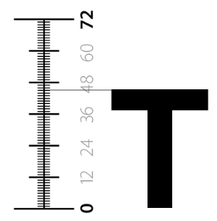
- What is the height of the type in points (pts)? L1
  - 45pt
  - 44pt
  - 46pt
  - 43pt

- How many inches are in 216 points? L2
  - 2.5in
  - 3in
  - 4in
  - 3.5in

- How many points are in 6 inches? L1
  - 480pt
  - 432pt
  - 414pt
  - 390pt

- When scanning an image to reproduce on a laser printer what is the range of dpi that should be used? L1
  - 300dpi – 720dpi
  - 250dpi – 800dpi
  - 600dpi – 2,400dpi
  - 60dpi – 90dpi

- What is the default operating system dpi on Apple/Macintosh computers? L1
  - 96dpi
  - 120dpi
  - 300dpi
  - 72dpi

GC1 - 3: Generate and evaluate file components.
Identify various desktop publishing applications and their uses.
Analyze color models and uses.

- What is the definition of image resolution? L1
  - The exchange of data within a file
  - The tracking of color in an image
  - The amount of detail an image holds
  - The mathematical creation of an image

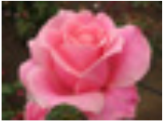
- This picture of a rose would be an example of which type of resolution? L1
  - Low resolution
  - High resolution
  - Vector resolution
  - Color resolution

- Which of the resolutions listed is an appropriate low resolution to use for a web site? L1
  - 133ppi
  - 32ppi
  - 300ppi
  - 72ppi

- The edge or border of a page layout is referred to as the ? L1
  - Gutter
  - Margin
  - Bleed
  - Trim

- When formatting a document to begin creating a piece of artwork, which of the following is NOT something that needs to be set up? L1
  - Resolution
  - Trims
  - Document size
  - Color mode

- When formatting a document, which of the following can be helpful to make sure that you align images, align images, align text, or maintain margins? L1
  - Trims marks
  - Bleed marks
  - Guides
  - Color mode marks

- Where should markings be located on a final printed piece to indicate where a fold should occur on a final printed image? L2
  - On the top of the document
  - As a typed note on the artboard
  - At the bottom of the document
  - In the notes in the document

- What term is used to identify when an image runs off the page after trimming? L1
  - Cut
  - Gutter
  - Margin
  - Bleed

- What are the 2 kinds of text that might be included in a multipage layout? L1
  - Decorative and simple text
  - Novelty and body text
  - Display and body text
  - Display and simple text

- A common file format used for digital photos is identified by which file extension? L2
  - .ai
  - .gif
  - .jpeg or .jpg
  - .docx

- A platform independent file format that provides an electronic image of text and/or graphics that looks like a printed document and can be viewed, printed, and electronically transmitted is identified by which of the following file extensions? L2
  - .pdf
  - .docx
  - .pub
  - .ai

- According to this image, what type of file would you anticipate is being set up? L3
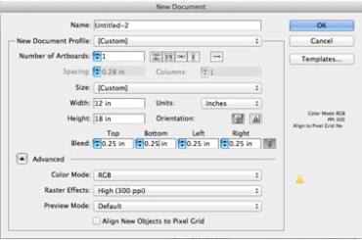
  - A piece of artwork for a final output via the computer screen
  - A piece of artwork for a final output via a laser printer
  - A piece of artwork for a final output via a television screen
  - A piece of artwork for a final output via a scanner.

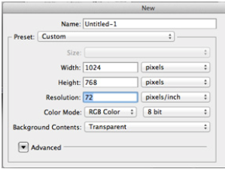
- Use this image to determine what kind of file type should be used to save the final document. L3
  - .ai
  - .jpg
  - .docx
  - .eps

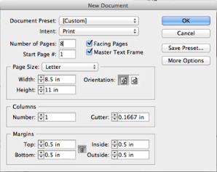
- Which of the following conclusions can you make from this New Document image? L3
  - This document will have multiple pages
  - This document will be used for a web page
  - This document is set up for a tri-fold brochure
  - This document will not contain any images

- What is the definition of vector-based artwork? L1
  - Digital art made of tiny pixels
  - Digital art made of open lines and shapes
  - Digital art that is made of solid lines and shapes
  - Digital art made of large pixels

- Rastor artwork is made up of ? L1
  - Large pixels
  - Solid lines and shapes
  - Tiny pixels
  - Open lines and shapes

- A real estate agent has requested you create a flyer to advertise for an open house. They have included several photos of the house to be used on the flyer. Which program will you use to make color corrections on the photos? L2
  - Illustrator
  - Photoshop
  - Microsoft Word
  - Premiere

- When manipulating anchor points and handles of an image that was created using Illustrator, what will you be altering? L2
  - The pixels that make up the appearance of the shapes
  - The boundaries that make up the appearance of the shapes
  - The paths that make up the appearance of the shapes
  - The alpha channel that makes up the appearance of the shapes

- What is the color called when any color generated by an ink (pure or mixed) is printed using a single run? L1
  - CMYK
  - Hex
  - Index
  - Spot

- While preparing a single color vector piece of artwork file for screen printing, you will be able to show the customer exactly what their final design will look like. The customer has requested a “hot pink” color on a navy blue tee shirt. In order to prepare your file for both viewing and printing positives, what kind of color should you use to show the “hot pink” on the computer screen? L3
  - Swatch
  - Spot
  - Gradient
  - Hex

GC1 – 4: Identify basic copyright issues for graphic communications and design industries to include understanding the use of Creative Commons copyright.

- The non-profit organization devoted to expanding the range of creative works available for others to build upon legally and to share is called what? L2
  - Creative Copyright
  - Creative Commons
  - Copyright Commons
  - Creative Copyright Commons

- What is the copyright license that lets others distribute, remix, and build upon your work, even commercially, as long as they credit you for the original creation called? L2
  - Attribution-ShareALike
  - Attribution-NoDerivs
  - Attribution
  - Attribution-NonCommercial

- What copyright license allows others to remix, tweak, and build upon your work even for commercial purposes, as long as they credit you and license their new creations in the identical terms? (Often compared to “copyleft” free and open source software licenses.) L2
  - Attribution-ShareALike
  - Attribution-NoDerivs
  - Attrivution-NonCommercial
  - Attribution-NonCommercial-ShareALike

- Which copyright license allows for redistribution, commercial and non-commercial, as long as it is passed along unchanged and in while, with credit to the original creator? L2
  - Attribution-NonCommercial
  - Attribution-NoDerivs
  - Attribution-NonCommercial-ShareALike
  - Attribution-NonCommercial-NoDerivs

- Which copyright license lets others remix, tweak, and build upon original work non-commercially, and although the new work must also acknowledge the original author and be non-commercial, the derivative works do not have to be licensed in the same terms. L2
  - Attribution-NonCommercial-ShareALike
  - Attribution-NonCommercial
  - Attribution-NonCommercial-NoDerivs
  - Attribution

- What copyright license lets others remix, tweak, and build upon original work non-commercially, as long as the author is credited and new work is licensed under identical terms? L2
  - Attribution-NonCommercial-NoDerivs
  - Attribution
  - Attribution-ShareALike
  - Attribution-NonCommercial-ShareALike

- What copyright license is the most restrictive, only allowing others to download works and share them with others as long as the original author is credited and without any changes of any kind? L2
  - Attribution-NonCommercial-NoDerivs
  - Attribution
  - Attribution-ShareALike
  - Attribution-NoDerivs

- Which term defines works whose intellectual property rights have expired, have been forfeited, or are inapplicable? L2
  - Copyright
  - Trademark
  - Public Domain
  - Registered

- Which of the following creative commons licenses DOES NOT allow for commercial use? L2
  - Attribution-NoDerivs
  - Attribution-NonCommercial
  - Attribution-ShareAlike
  - Attribution

- Which of the following creative commons licenses DOES NOT allow for work to be changed or “remixed”? L2
  - Attribution-NonCommercial-NoDerivs
  - Attribution-ShareAlike
  - Attribution-NonCommercial
  - Attribution-NoDerivs

- What is the monetary fine for each instance of copyright infringement? L2
  - $200 - $150,000
  - $200 - $100,000
  - $2,000 - $10,000
  - $15,000 - $150,000

- What is the possible jail sentence for each instance of copyright infringement? L2
  - Up to 5 years
  - Up to 10 years
  - Up to 15 months
  - Up to 5 months

- What is a recognizable sign, design, or expression, which identifies products or services of a particular source from those of others? L2
  - Copyright
  - Patent
  - Domain
  - Trademark

- Which of the following is a legal right created by the law of a country that grants the creator of original work exclusive rights to its use and distribution, usually for a limited time, with the intention of enabling the creator to receive compensation for their intellectual effort? L2
  - Copyright
  - Trademark
  - Patent
  - Domain

- Which of the following is a set of exclusive rights granted by a sovereign state to an inventor or creator for a limited period of time in exchange for detailed public disclosure of an invention? L2
  - Copyright
  - Patent
  - Trademark
  - Domain

- The standard length of an author’s copyrighted work is which of the following? L2
  - Life of the author plus 50 years
  - Life of the author plus 120 years
  - Life of the author plus 70 years
  - Life of the author plus 90 years

- If you spend 3 hours on a custom design for a client and charge them $12.00/hour for a total bill of $36.00 what fee system are you employing? L1
  - Time-based pricing
  - Fixed fee pricing
  - Value-based pricing
  - Product pricing

- If you charge a client $100 per design regardless of the time spent to create each work what fee system are you employing? L1
  - Fixed fee pricing
  - Time-based pricing
  - Value-based pricing
  - Product fee pricing

- If you charge a large, established business $300 for a design intended for national exposure and a small or new business $50 for a design intended for local or limited exposure what fee system are you employing? L1
  - Fixed fee pricing
  - Time-based pricing
  - Value-based pricing
  - Product fee pricing

- Which of the following would MOST likely be an example of a “high risk for non-payment” client? L2
  - Accounting firm
  - New hair salon
  - Law firm
  - Tech firm looking for rebranding

GC1 – 5: Understand and demonstrate how to capture an image.
Identify and demonstrate the components of graphic communication projects.

- You have been hired as a graphic designer to create a tri-fold brochure for the park district. They have given you several hard copies of photographs to include in the brochure. The final brochure will be produced at 100%. When scanning the images, what resolution should be used? L3
  - 133ppi
  - 72dpi
  - 133dpi
  - 72ppi

- What does the acronym “ppi” represent? L1
  - Points per inch
  - Pixels per inch
  - Points per increment
  - Pixels per increment

- What unit of measurement would be appropriate for images on a computer screen? L1
  - DPI
  - LPI
  - In
  - PPI

- What is the appropriate unit of measurement to use for printed images? L1
  - PPI
  - In
  - DPI
  - M

- Which of the resolutions is best for scanning an image to be used on a website? L1
  - 72ppi
  - 133ppi
  - 300ppi
  - 600ppi

- In order to maintain quality when laser printing an image, the image should be at least what resolution? L2
  - 300dpi
  - 96dpi
  - 72 dpi
  - 133dpi

- An image has a resolution of 72dpi, what is the intended output? L1
  - Web page
  - Offset printing
  - Screen printing
  - Flexography

- What happens when you enlarge a raster image more than 15 percent? L2
  - Image quality increases
  - Image quality decreases
  - Image quality vectorizes
  - Image quality sharpens

- What is the appropriate resolution to scan an image that is to be used on a business card? L2
  - 72 dpi
  - 96 dpi
  - 133 dpi
  - 300 dpi

- While working in a vector based art program, what happens when you enlarge a piece of raster artwork more than twice its original size? L3
  - The artwork will maintain its appearance.
  - The artwork will convert to vector and look better
  - The artwork will appear jagged and the quality will decrease.
  - The artwork can never be enlarged more than 30% in a vector program.

- While working in a vector based art program, you enlarge a piece of vector artwork more than twice its original size. What is the end result of that artworks appearance? L3
  - The vector artwork looks exactly the same except it is bigger than it was.
  - The vector artwork has jagged edges and the quality is not good.
  - The vector artwork cannot be enlarged that much in a vector program.
  - The vector artwork is converted to raster artwork and it has the same appearance.

- What happens when you change a raster image from 72 dpi to 300 dpi, keep the same dimensions on screen, and print it out? L3
  - The image will have better quality when printed
  - The image will be smaller than it was on screen when printed
  - The image will have less information per inch when printed
  - The image will have more information per inch when printed

- A company has asked you to make a printable brochure but the images they can provide are only accessible from the internet and are very small when you download them to your computer. What is your best option for enlarging the images for the brochure? L3
  - Use a vector program to upsample the pixel data
  - Use a raster based program to downsample the pixel data
  - Use a raster based program to upsample the pixel data
  - Use a vector based program to downsample the pixel data

- Why does an image look good on the computer screen but have a lower quality when printed out? L1
  - The pixel data on a computer screen usually displays 72ppi
  - The dot data on a computer screen usually displays 300dpi
  - The pixel data on a computer screen usually displays 133ppi
  - The dot data on a computer screen usually displays 133dpi

- If a raster image is 3136x2352 pixels in size and is 72ppi, why can the image be used for a quality print for a brochure? L3
  - The pixel dimension is large and contains enough data to be reduced
  - The resolution is high enough to produce a quality print but only at the original size
  - The pixel dimension is small and inversely holds more data when reduced
  - The resolution will decrease when the image is reduced and print a quality image

- What difference would you see between two printed images with the same image dimensions where one has a resolution of 96dpi and the other is 300dpi? L2
  - The 300dpi image would print smaller
  - The 96dpi image will print smaller
  - The images would print the same
  - The image color will be better in the 96 dpi image

- What is the term used to identify when an image is cut to omit a portion of the image? L1
  - Resize
  - Crop
  - Expand
  - Upsample

- Which of these options is NOT a reliable method for obtaining an image? L1
  - Video
  - Digital camera
  - Scanner
  - Internet

- Which term refers to an image in which colors and shades of gray smoothly merge into the neighboring colors or shades? L1
  - Raster
  - Vector
  - Continuous tone
  - Digital image

- When creating a color halftone to be laser printed, what angles should be used to avoid a moiré pattern? L2
  - 15°, 30°, 45°, 70°
  - 0°, 15°, 45°, 75°
  - 30°, 45°, 75°, 130°
  - 75°, 90°, 130°, 145°
GC1 – 6: Identify the utilization of the elements of design.
Demonstrate the ability to properly integrate text in a computer-generated page layout.

- Which element of design is represented here? L1
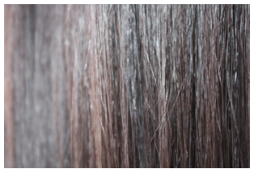
  - Shape
  - Color
  - Mass
  - Texture

- The following represents which element of design? L1
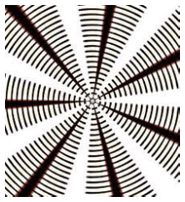
  - Value
  - Line
  - Mass
  - Shape

- Which typeface guideline is the red arrow indicating? L1
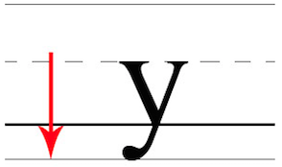
  - Ascender
  - Baseline
  - X-Height
  - Descender

- Which style of typeface does this example represent? L1
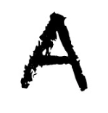
  - Decorative
  - Serif
  - Block Serif
  - Black Letter

- What character element should be adjusted to increase legibility in this image? L3
  - Leading
  - Scaling
  - Kerning
  - Tracking

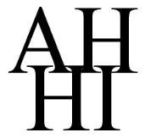
- What character element should be adjusted to increase legibility in this image? L3
  - Leading
  - Kerning
  - Alignment
  - Scaling

- If given the following business card to personalize how should contact information be aligned on the front of the card? L2
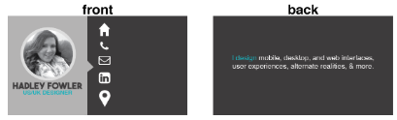
  - Left aligned
  - Right aligned
  - Centered
  - Justified

- Which two pieces of information should be identified to effectively create a flyer for a neighborhood charity fundraiser? L2
  - Education level of attendees and demographics of the neighborhood
  - Demographics of the neighborhood and purpose of the fundraiser
  - Occupation of attendees and education level of attendees
  - Purpose of the fundraiser and occupation of attendees

- Which of the following design principles are depicted below? L2
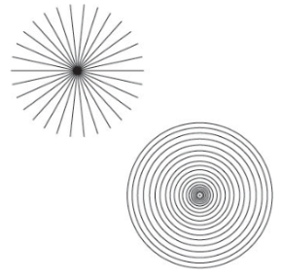
  - Radiation
  - Rotation
  - Reflection
  - Raster

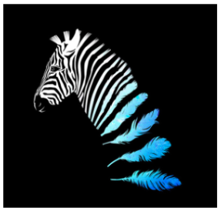
- This image includes examples of which of the following design principles? L2

  - Radiation
  - Unity
  - Rotation
  - Transition

- What is the result of lines coming together for form right angles (i.e. a doorway or sofa corner)? L2
  - Contrast
  - Opposition
  - Proximity
  - Repetition

- Using different styles or materials in a design creates which of the following? L2
  - Opposition
  - Variety
  - Repetition
  - Proximity

- When using space/forms, which of the following can create a sense of direction? L2
  - Shapes
  - Lines
  - Colors
  - Textures

- This image is an example of what types of colors? L1
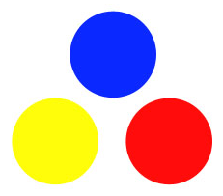
  - Secondary colors
  - Tertiary colors
  - Analogous colors
  - Primary colors

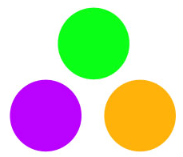
- The image below is an example of what types of colors? L1
  - Secondary colors
  - Primary colors
  - Tertiary colors
  - Analogous colors

- Which of the following would be an example of an analogous color set? L2
  - Red-Orange, Orange, Violet
  - Yellow, Yellow-Green, Blue-Green
  - Red-Violet, Red, Red-Orange
  - Blue, Violet, Red-Violet

- The colors yellow-orange, red-orange, red-purple, blue-purple, and yellow-green are indicated below. These are examples of what colors? L1

  - Analogous Colors
  - Complementary Colors
  - Secondary Colors
  - Tertiary Colors

- When creating a new document set to Profile: Web, what are the default color mode and raster effect settings? L2
  - Color Mode> RGB and Raster Effects: Medium (150ppi)
  - Color Mode> RGB and Raster Effects: Screen (72ppi)
  - Color Mode> CMYK and Raster Effects: Screen (72ppi)
  - Color Mode> CMYK and Raster Effects: Print (300dpi)

- When saving for print which of the following file types is NOT optimal? L2
  - .png
  - .eps
  - .pdf
  - .jpg

- Which of these options would be described as a preliminary design that consists of rapidly executed drawings used to begin the creative process? L1
  - Thumbnail sketches
  - Mock-up
  - Rough draft
  - Storyboard

Assignment One: Logo L3
Client: Flight School

Assignment: The owners of a new aerial instruction school for teens and adults have hired you to create a new logo for this service being offered to community members. The owner of Flight School has a calling to help the public better understand plane mechanics, technical skills, and piloting abilities.

To start with, you have been hired to create a logo. Up until this point, this young business has not had a logo – just plain text arrangement of their name brand “Flight School”. This logo will be used as branding for their new service, used on their website, electronic communication, social media, teaching aids, brochures, business cards, and other materials. The required text for the logo is “Flight School”. They have given you free reign with colors, but ask that it make a lasting impression representing the potential they wish to offer their students. The logo design
MUST NOT be strictly typographic. It must incorporate graphic elements or illustrations along with the name. This logo will be reproduced on different materials, and should be able to be scaled to fit a wide range of sizes and mediums (pens to billboards). The logo should represent the valuable programs that Flight School offers, which is to help their clients recognize their ability to soar. It must appeal to teens and young adults as well as their parents and older community members.

*Your logo should fill an 8in x 8in artboard.

*Save your work as your name in the native format.

*Do not merge layers.

Assignment Two: Billboard L3
Client: Flight School

Assignment: An exciting aspect of their advertising campaign will involve Billboards in the largest markets in Illinois. Billboard Advertising can reach your target market audience for much less than what you will pay for traditional radio or TV advertising and can impact thousands of prospective clients.

The billboard needs to make this new flight school known to many people from all walks of life and will feature the new logo and branding that you have designed. In addition to the logo, a powerful and compelling creative slogan or tag line should be a part of the design of the billboard. The standard size of the billboard to be placed will be 40ft wide x 19ft tall. The art file to be provided to the billboard company needs to be developed at 20in x 9.5in in CMYK. Art should not bleed past the edge of the file. You should allow a 0.25in safety margin on all sides for the headline, logo, and other text used on the piece. Remember how this advertisement will be read by your clients – from hundreds of feet away while traveling past it on the roadways and highways of Illinois.

Make it noticeable!

*Save you work as your name in the native format.

*Do not merge layers.

